Elevator Pitch:

Yes, let me tell you about myself. I've worked as a contractor for the past 5 years, with that came the experience of working with on-premise and cloud environments. I have been part of migration projects in which I moved Apache ETL pipelines to AWS. I code in multiple languages including Java, Scala, Python, and SQL. I've worked with SQL and NoSQL Database/Data warehouse. I'm familiar with AWS, Cloudera, and Horton works platforms. In my current role, Sr. Big Data Engineer, I'm responsible for processing data from IOT Sensors coming from various types of vehicles.

**Meineke Car Care Center** | Charlotte, NC Oct,2018 – Now

Pipeline Info: -Migration Pipeline -AWS Development -HDFS -HBase -Hive –

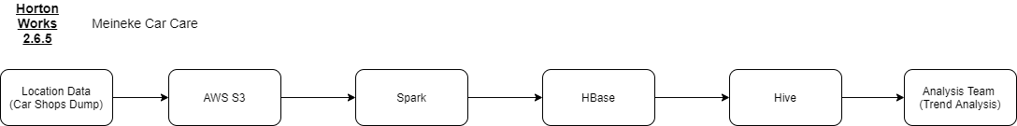

**EBay** | San Jose, CA Jul,2017 – Oct,2018

Pipeline Info: -Full Cloud -Streaming -EMR Cluster Set up

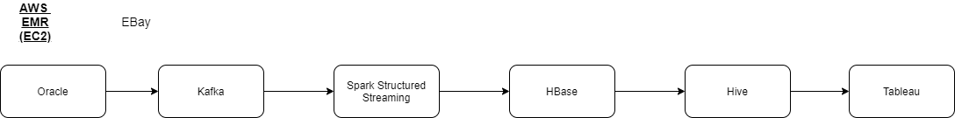

**Century 21** | Madison, NJ June,2016 – Jan,2017

Pipeline Info: -On-prem -Oozie batching -MongoDB -Flume

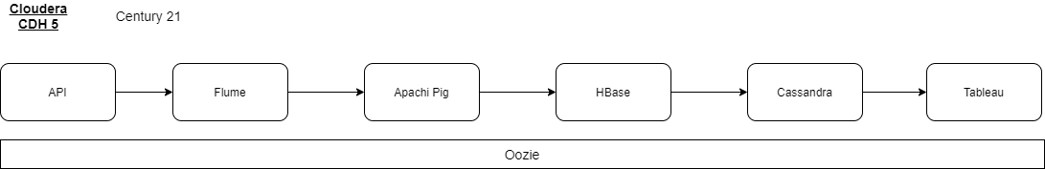

**JP Morgan** | New York, NY Jan,2015 – June,2016

Pipeline Info: -Cloud Heavy -Redshift – AWS -HDFS migration

